**Hbase Assignment1**

**TASK2**

Access the hbase data from hive

For the above hbase table create a corresponding hive table and access the data by running queries in hive

Created external table in hive below:

hive> CREATE EXTERNAL TABLE stock_symbol_various_user_ToHBase(rowkey string,stock_symbol string, commentid string, userid string, displayna

me string, active string, comment string)STORED BY 'org.apache.hadoop.hive.hbase.HBaseStorageHandler'WITH SERDEPROPERTIES ('hbase.columns.m

apping' = ':key,sampledata:stock,sampledata:commentid,sampledata:userid,sampledata:displayname,sampledata:active,sampledata:comment')TBLPRO

PERTIES ('hbase.table.name' = 'Savita_db:stock');

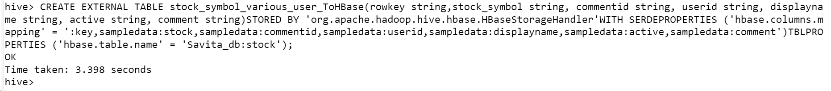

hive> desc stock_symbol_various_user_ToHBase;

hive> desc formatted stock_symbol_various_user_ToHBase;

1. What are the various comments given by all the users?

hive> select userid,comment from stock_symbol_various_user_ToHBase;

OK

User1 I have this one on my radar.

User1 Interesting value proposition but too early to know if they will survive.

User2 I like this one but would suggest waiting a few months.

User2 Not obvious yet but this stock is gonna be a huge winner.

User3 Buy it now before the rush.

User3 Dump this one fast!

Time taken: 0.657 seconds, Fetched: 6 row(s)

1. What are the comments by user3?

hive> select userid, comment from stock_symbol_various_user_ToHBase where userid ='User3';

Total MapReduce CPU Time Spent: 8 seconds 340 msec

OK

User3 Buy it now before the rush.

User3 Dump this one fast!

Time taken: 34.833 seconds, Fetched: 2 row(s)

1. Which users have inactive comments?

hive> select userid from stock_symbol_various_user_ToHBase where Active='False';

Total MapReduce CPU Time Spent: 5 seconds 430 msec

OK

User2

User3

Time taken: 20.031 seconds, Fetched: 2 row(s)

